H2 Prelim 2010 Essay answers

1 | (a) | (i) | [O]: Zn + 4OH⁻ → ZnO₂²⁻ + 2H₂O + 2e  [R]: HgO + H₂O + 2e → Hg + 2OH⁻  Zn + 2OH⁻ + HgO → ZnO₂²⁻ + H₂O + Hg
 |  | (ii) | Emf = +0.10 – (-1.22) = +1.32 V (feasible)
 |  | (iii) | Electron will flow from Zn electrode to HgO electrode  OR  Electron will flow from oxidation electrode to reduction electrode  OR  Electron will flow from ZnO₂²⁻/Zn half-cell to HgO/Hg half-cell .
 |  | (iv) | Q = It = 0.1 x 10⁻³(10 x 7 x 24 x 60 x 60)  = 604.8 C  HgO + H₂O + 2e ⬄ Hg + 2OH⁻  No. Of moles of electrons = 604.8 / 96500 = 6.267 x 10⁻³  No. of moles of HgO = 6.267 x 10⁻³ x ½  = 3.134 x 10⁻³  mass of HgO present initially = (3.134 x 10⁻³ ) x 217.0  = 0.680 g
 | (b) | (i) | 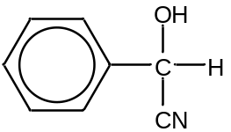
 |  | (ii) | Nucleophilic substitution / esterification/ condensation
 |  | (iii) | I: LiAlH₄ ; in dry ether OR H₂(g), Ni catalyst, high temperature, high pressure  II: dilute HCl/H₂SO₄ ; heat  III: CH₃CH(OH)COOH ; conc H₂SO₄, heat  OR  CH₃CH(OH)COCl; room temperature
 |  | (iv) | HCN is bronsted acid.  NaCN is a catalyst that provide the initial nucleophile, CN–
 |  | (v) | In propanal, the ethyl group is a smaller group than the bulky benzene ring in benzaldehyde. There is less steric hindrance for CN– to attack the carbonyl carbon in propanal. Thus, propanal reacts with HCN at a faster rate
 |  | (vi) | Both benzaldehyde & propanal have simple molecular structures. With permanent dipole- permanent dipole interaction between the respective molecules (accept van der Waal’s forces of attraction between molecules). Benzaldehyde has larger electron cloud than propanal thus more easily polarised.Thus, stronger permanent dipole- permanent dipole interaction between benzaldehyde molecules. More energy is needed to overcome the stronger intermolecular forces for benzaldehyde. Thus, benzaldehyde has a higher boiling point.
 | (d) | (i) | Hydrogen bond
 |  | (ii) | Spider silk is more elastic than silkworm silk as it has less beta sheets, hence held together by lesser hydrogen bonds.  OR  Silkworm silk absorbs water more easily as it can form more hydrogen bonds.

2 | (a) |  | Nucleophilic substitution (S_{N}1)  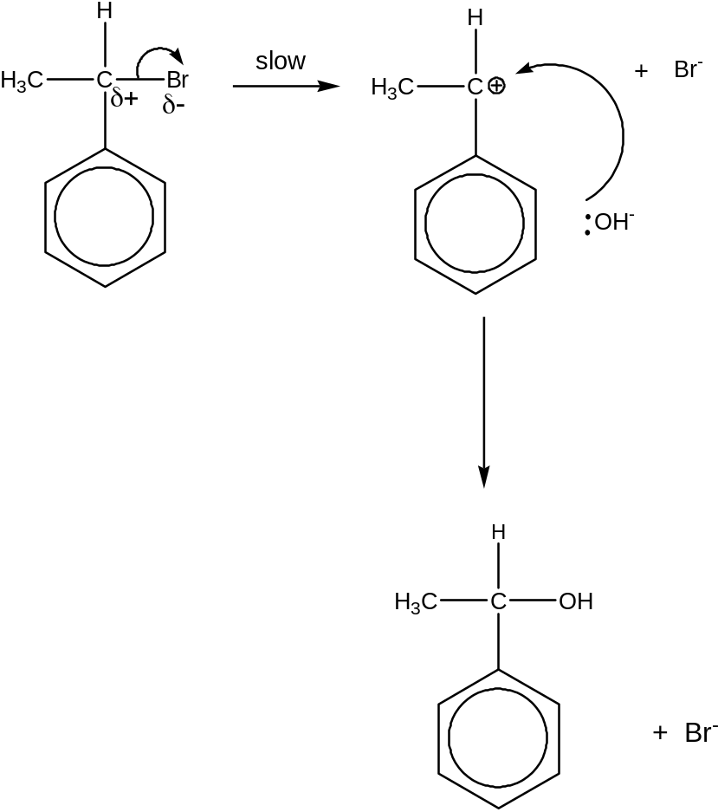  Nucleophilic substitution (S_{N}2)  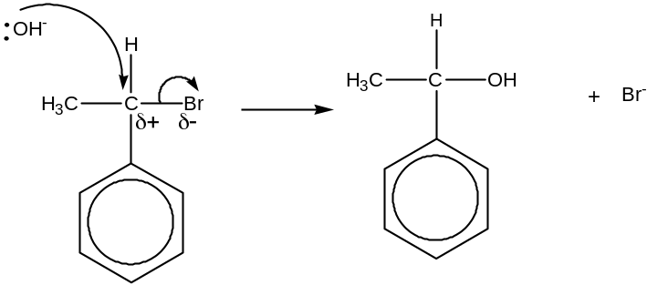
 | (b) | 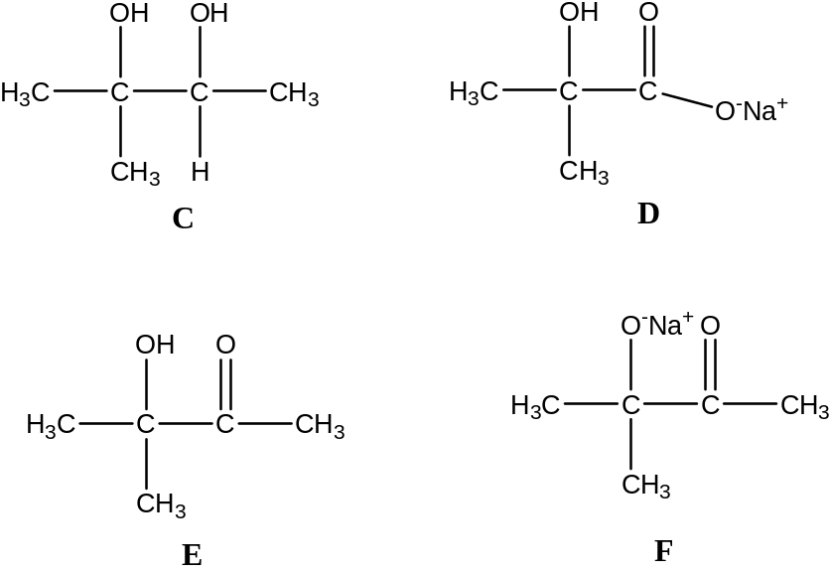
 | (ci) | ΔH = Bond broken- bond formed  = 2560 – 2385  = +175 kJmol⁻¹
  Bond broken kJ mol⁻¹ |  | Bond formed kJ mol⁻¹
  C-H | 4 x 410 | C≡O | 1 x 1077
  O-H | 2 x 460 | H-H | 3 x 436
  Total | 2560 | Total | 2385
 | (ii) | The sign should be positive as there is an increase in gaseous molecules.  OR There are more ways of arranging the particles in the system and system becomes more disorderly.
 | (iii) | For the reaction to be feasible, ΔG^{θ} < 0  ∆G ^{θ} = ∆H ^{θ} − T∆S ^{θ}  ∆H ^{θ} − T∆S ^{θ} < 0  +175 – T(216X10⁻³) < 0  +175 < T(216X10⁻³)  T > 810 K
 | (d) | (i) | Carbon monoxide contains a lone pair of electrons which can dative bond to the iron centre OR as ligand.
 | (ii) | It contains available empty or half-filled d-orbitals.
 | (iii) | No. of moles of vanadium in one sea squirt = 100X10⁻³ /1000 X300  = 0.03 moles  No. of moles of vanadium in 1 litre of sea water = 7.1X10⁻⁶/ 50.9  = 1.395 X10⁻⁷ moles  No. of litres of sea water each sea squirt has to process = 0.03/1.395X10⁻⁷  = 2.15X10⁵ litre  Mass of sea water to process in kg = 2.15 X10⁵ X 1.03  = 2.22 X10⁵ kg

3 | (a) | (i) | 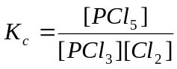
 | (ii) | 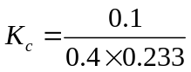  = 1.07 mol⁻¹ dm³
   | PCl₃ (g) + Cl₂ (g) PCl₅ (g)
  Initial / mol | 1 | 1.5 | 0
  Change / mol | 1 - 0.7  = 0.3 | -0.3 | + 0.3
  Eqm / mol | 0.7 | 1.2 | 0.3
  Eqm / mol dm⁻³ | 0.7/3 = 0.233 | 0.4 | 0.1
 |  | (iii) | No effect on K_{c} as it is only affected by temperature.
 | (b) | (i) | Empirical formula: Na₄FeC₆N₆
   | Na | Fe | C | N
  Mass in 100g | 30.26 | 18.42 | 23.68 | 27.64
  No. of moles | 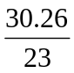= 1.32 | 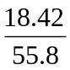= 0.330 | 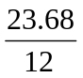= 1.97 | 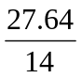= 1.97
  Simplest Ratio | 4 | 1 | 6 | 6
 |  | (ii) | FeSO₄ + 6NaCN → Na₄FeC₆N₆ + Na₂SO₄
 |  | (iii) | Chlorine is an oxidising agent.
 |  | (iv) | Na₃[Fe(CN)₆]
 |  | (v) | [O] : [Fe(CN)₆]⁴⁻ + e → [Fe(CN)₆]³⁻
 |  |  | [R]: Cl₂ + 2e → 2Cl⁻
 |  |  | Overall: Cl₂ + 2[Fe(CN)₆]⁴⁻ → 2Cl⁻ + 2[Fe(CN)₆]³⁻
 | (c) | (i) | Add gaseous SO₃ to deuterium oxide, D₂O  SO₃(g) + D₂O(l) 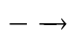 D₂SO₄(aq)
 |  | (ii) | Al(OH)₃ (s) will dissolve  2Al(OH)₃ (s) + 3D₂SO₄ (aq) Al₂(SO₄)₃(aq) + 6HDO(l)  Al(OH)₃ (s) behave as a base & reacts with D₂SO₄ to form soluble salt.  Al(OH)₃ (s) + NaOD(aq) NaAl(OH)₃OD(aq)  Al(OH)₃ (s) behave as an acid & reacts with NaOD(aq) to give colourless complex solution.
 | (d) | Sodium burns with a yellow flame.  4Na(s) + O₂(g) 2Na₂O(s)  Sulfur burns with a bright blue flame.  S(s) + O₂(g) SO₂(g)
 | (e) | Test: Add KMnO₄ in dilute H₂SO₄ and heat.  Observation for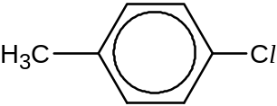 :  Purple KMnO₄ decolourises, white ppt observed.  Observation for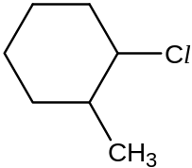 :  Purple KMnO₄ does not decolourise.  OR  Test: Add aq NaOH and heat followed by excess dilute HNO₃ and AgNO₃.  Observation for : No white ppt formed.  Observation for: White ppt formed.

4 | (a) |  | (i) | O : 1s²2s²2p⁴
 |  |  | (ii) | After the removal of the first electron, the remaining electrons are more strongly attracted towards the nucleus since the nuclear charge remains unchanged. Thus, more energy is needed to remove the second electron.
 |  |  | (iii) | Sulfur is in Period 3 and hence has the availability of 3d orbitals to expand beyond its octet structure OR oxygen cannot expand its octet due to the absence of 3d orbitals.
 |  |  | (iv)
I |  | pH = - log [H⁺]  = - log (2.71 x 10⁻³)  = 2.57
II |  | Let HA represents glycolic acid  Ka = 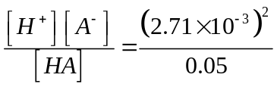  = 1.47 x 10⁻⁴ mol dm⁻³

 |  |  |  | (v) |  | Effect of CO₂ and water vapour:  These gases allow the visible radiation from the sun to reach the earth’s surface but trap some of the infrared radiation which is emitted by the earth. This leads to the greenhouse effect.  OR  Effect of CO :  When breathe in, CO will combine with haemoglobin in human blood to form carboxyhaemoglobin, which is a very stable complex. Its formation will prevent oxygen from being absorbed by blood and transported to other parts of the body OR cause suffocation.
 | (b)
(i) I |  |  | Comparing expt 1 and 2, when [GABE) doubles keeping [NaOH] constant, the rate also double. Hence the order with respect to GABE is one.
(i) II |  |  | Using data from expt 2 and 3,  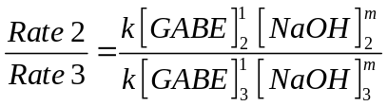  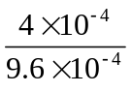= 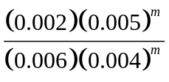  1.25 = (1.25)^{m}  m = 1  Order with respect to NaOH = 1
(ii) |  |  | Rate = k[GABE][NaOH]
 |  | (iii) |  |  | Reaction I : PCl₅ or PBr₃, room temp  Reaction II : Ethanolic KCN, heat with reflux  Reaction III : LiAlH₄ , dry ether  G :  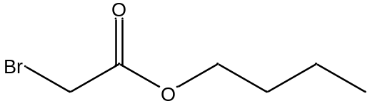  OR  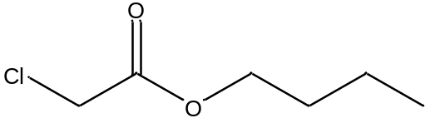 (depend on reagent used for reaction I)  OR  Reaction I : dilute HCl, heat  Reaction II : 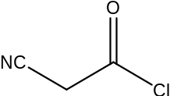 , room temperature  Reaction III : LiAlH₄, dry ether  G: 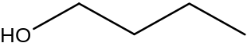
 |  | (c) |  |  | Test : Tollens’ reagent, warm  Observation : Silver mirror formed in glyoxylic acid; no silver mirror in glycolic acid  OR  Test : Fehling’s reagent, warm  Observation : Brick red ppt & blue Cu²⁺ decolorises in glyoxylic acid; no brick red ppt in glycolic acid  OR  Test : 24-dinitrophenylhydrazine  Observation : Orange ppt seen in glyoxylic acid; no orange ppt in glycolic acid

 | (d) | C : H about 1 : 1, means H has benzene ring  Insolubility of H in dilute acids indicate that H is not an amine,  H is likely to be an amide.  H undergoes acid-base reaction since it reacts readily with alkalis.  OR H contains an acidic group.  Solubility of H in aq NaOH and reaction with aq Br₂ indicate that H is a phenol.  H undergoes electrophilic substitution with bromine to give Q C₈H₇NO₂Br₂  H contains phenol group.  Substitution of two Br atoms into the benzene ring indicates that the side group is on carbon-2 or carbon-4 with respect to the phenolic -OH group.  On warming with dilute hydrochloric acid, H undergoes acid hydrolysis (or hydrolyses) to form J and K.  K is soluble in water, which means that K is a salt (amine salt).  J reacts with sodium carbonate to release colourless gas, which means that J has –COOH group
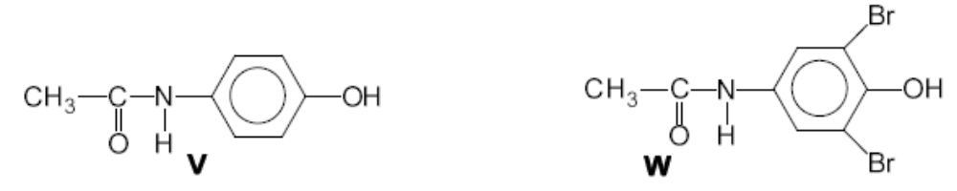
H ** the side-chain can also be at position 2.

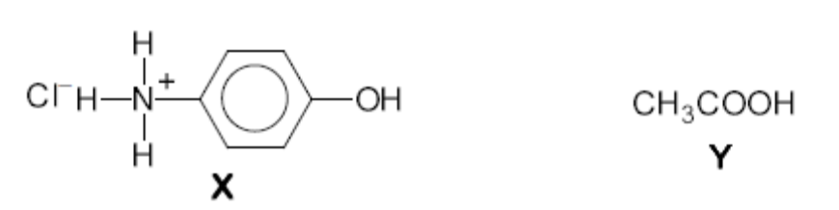
K ** the position of side-chain would depend on structure H

CH₃COOH
J

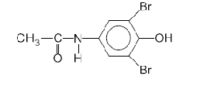
Q
[Br can also be substituted at the 2nd and 4th position if the side chain is at the 2nd position]

5 | (a) | (i)
Step 1: Steam, conc H₃PO₄ , 300 ºC, 60 atm
Step 2: conc H₂SO₄ , 170 ºC / Al₂O₃ , heat at 350 ºC

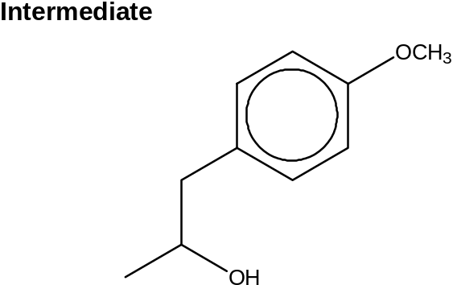

OR:

Step 1: HBr(g), room temp / HCl(g), room temp
Step 2: ethanolic KOH / NaOH , heat with reflux

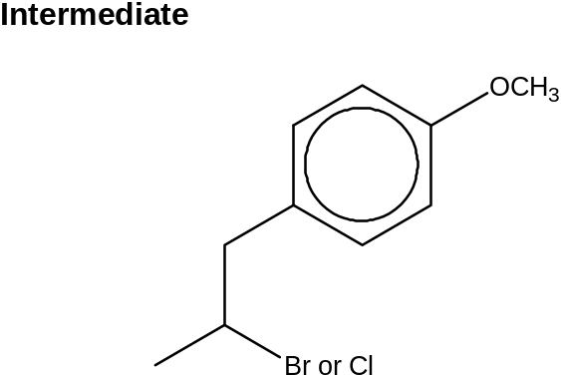
 |  | (ii) | 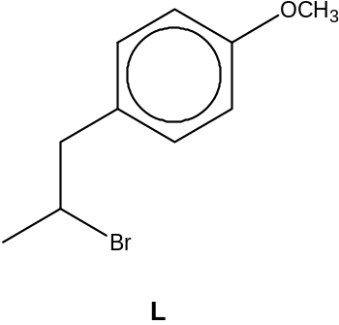Other halogen atom, Cl or I allowed.

 |  | (iii) | Geometric or cis-trans isomerism.
 |  | (iv) | Trans-anethole is the predominant isomer in the reaction product mixture as trans-anethole is more stable than cis-anethole.  The electron cloud of the 2 R groups on the C=C double bond of trans-anethole are opposite each other, hence minimise steric repulsion / steric hindrance between them.
 | (b)
M or N (or both) contains a C=C double bond (alkene). They react with aqueous bromine through electrophilic addition.
M and N undergo oxidative cleavage/oxidation with hot acidified KMnO₄.
N contains a terminal double bond / alkene since there are 4 C atoms left after oxidative cleavage.
P contains the structure 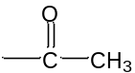 as it undergoes mild oxidation with alkaline aqueous iodine.
The pale yellow ppt is CHI₃.
P must contain the carboxylic acid group as it can react with Na₂CO₃.
Since oxidative cleavage of M gave only propanone and CO₂, the CO₂ must come from a 2-carbon unit, which is ethanedioic acid.
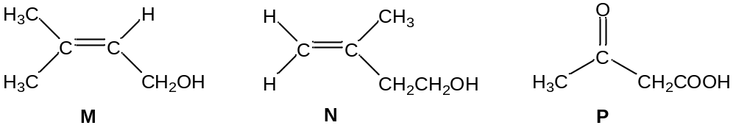
 | (c) | (i) | E^{ө}  Br₂ + 2e 2Br⁻ +1.07V  F₂ + 2e 2F⁻ +2.87V  O₂ + 4H⁺ + 4e 2H₂O +1.23V  From the E^{ө} values, since E^{ө}_{F2/F-} is more positive than E^{ө}_{Br2/Br-}, F₂ is a stronger oxidizing agent than Br₂ and hence able to oxidise water to oxygen gas.  F₂ + 2e 2F⁻ +2.87V  O₂ + 4H⁺ + 4e 2H₂O +1.23V  E^{ө}_{cell} = E^{ө}_{red} - E^{ө}_{ox} = +2.87 – (+1.23)  = +1.64V >0  Since E^{ө}_{cell} >0, the reaction is energetically feasible.  Overall: F₂(g) + H₂O(l) → 2HF(aq) + ½O₂ (g)  Br₂ + 2e 2Br⁻ +1.07V  O₂ + 4H⁺ + 4e 2H₂O +1.23V  E^{ө}_{cell} = E^{ө}_{red} - E^{ө}_{ox} = +1.07 – (+1.23) = -0.16V <0  Since E^{ө}_{cell} <0, the reaction is not energetically feasible, hence no gas is evolved.
 |  | (ii) | E^{ө}  Cl₂ + 2e 2Cl⁻ +1.36V  Fe³⁺ + e Fe²⁺ +0.77V  E^{ө}_{cell} = E^{ө}_{red} - E^{ө}_{ox} = +1.36 – (+0.77)  = +0.56V >0  Since E^{ө}_{cell} >0, the reaction is energetically feasible.  Overall: Cl₂(aq) + 2Fe²⁺(aq) → 2Cl⁻(aq) + 2Fe³⁺ (aq)  The reddish brown ppt is due to the formation of Fe(OH)₃(s).  Fe³⁺(aq) + 3OH⁻(aq) → Fe(OH)₃(s)

